**DUE: Feb 25, 2022**

Lecture 9: Tuesday Feb 08, 2022

<https://ncl.instructure.com/courses/39984/pages/lecture-9-presentation-skills?module_item_id=2109391>

**What to include:** (do we include Timeline/Gantt Chart on this? They mentioned that previous years are different so we’re prob gonna have different stuff in our presentations)

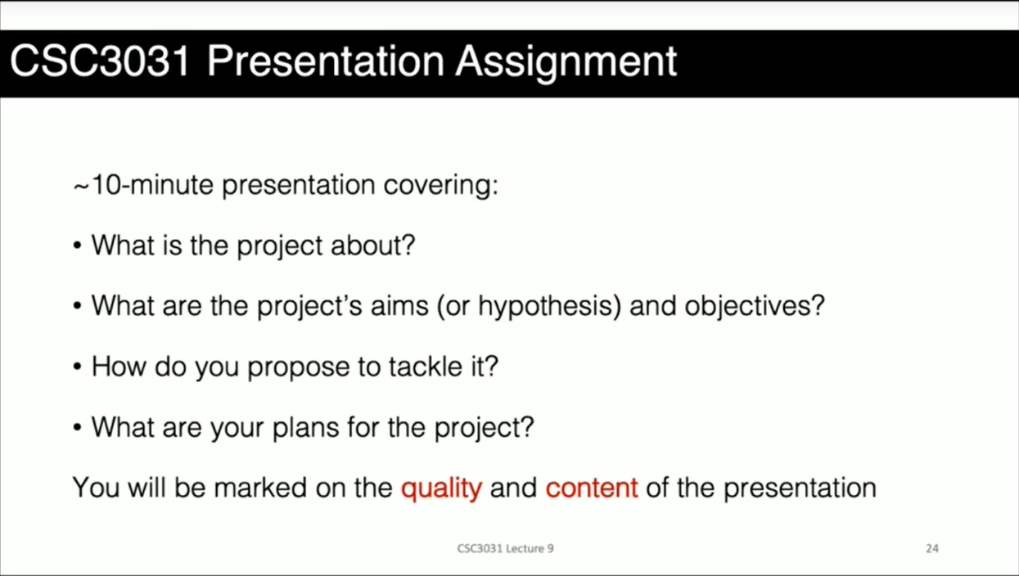

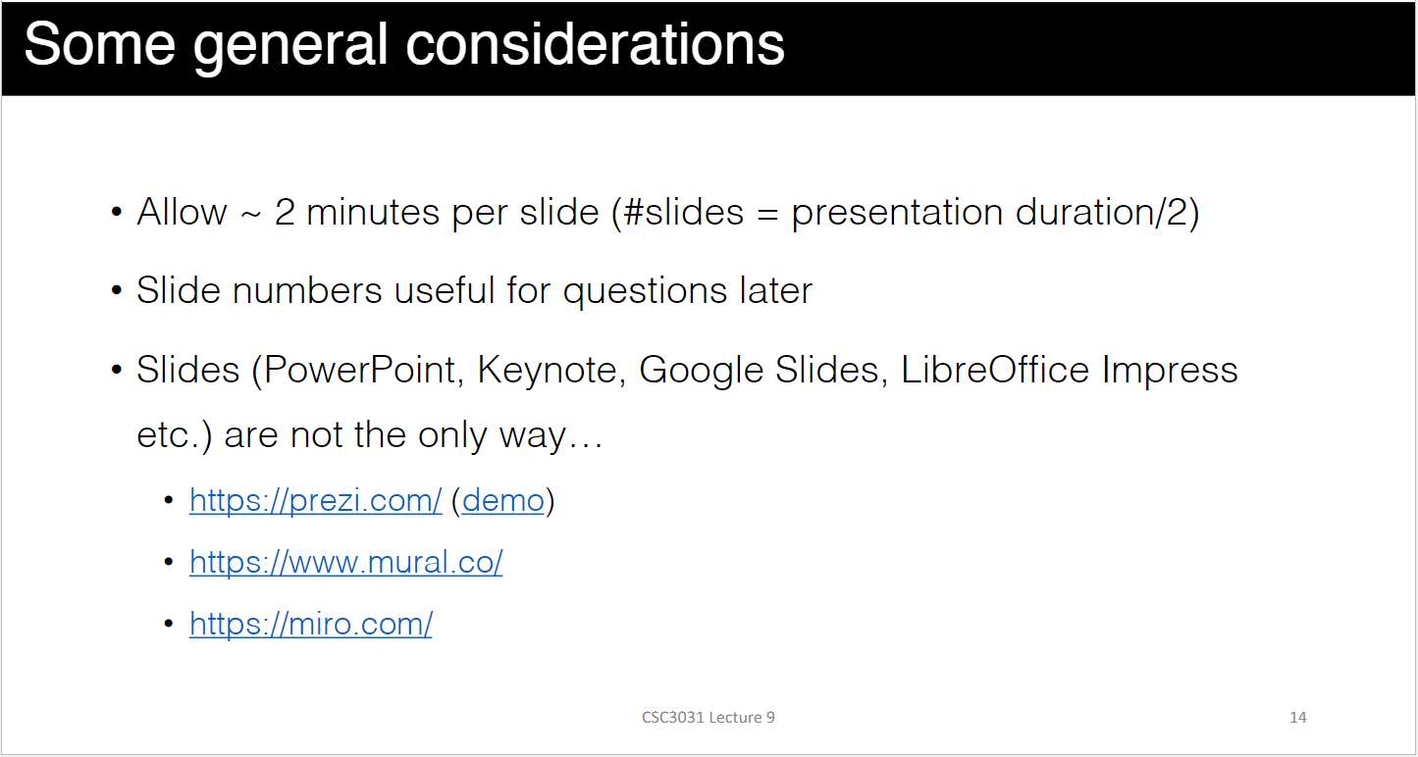

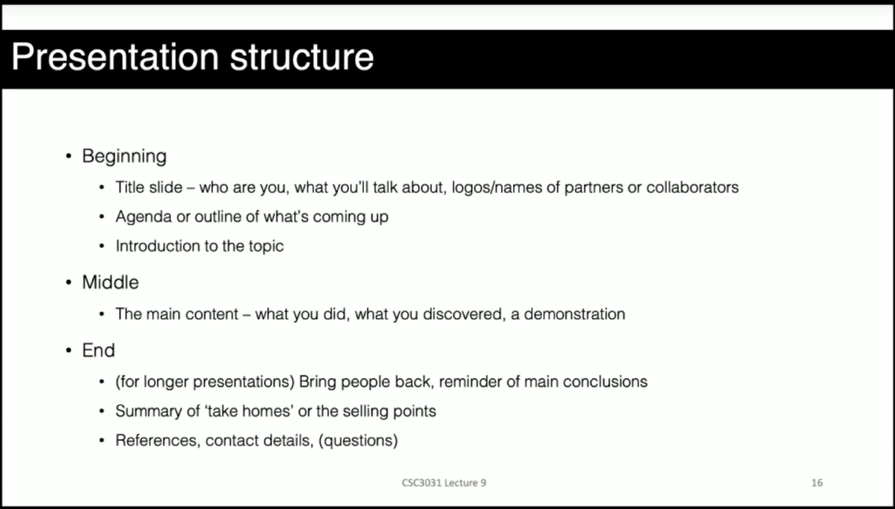

I will start with title slide

Then Outline what I’m going to talk about. -- “I’m going to discuss all this shit today.”

Start with first topic -- “To start, I’ll begin with this”

**Example presentations:**

<https://ncl.instructure.com/courses/39984/pages/examples-of-presentations?module_item_id=2104947>

1. **What is the project about?**

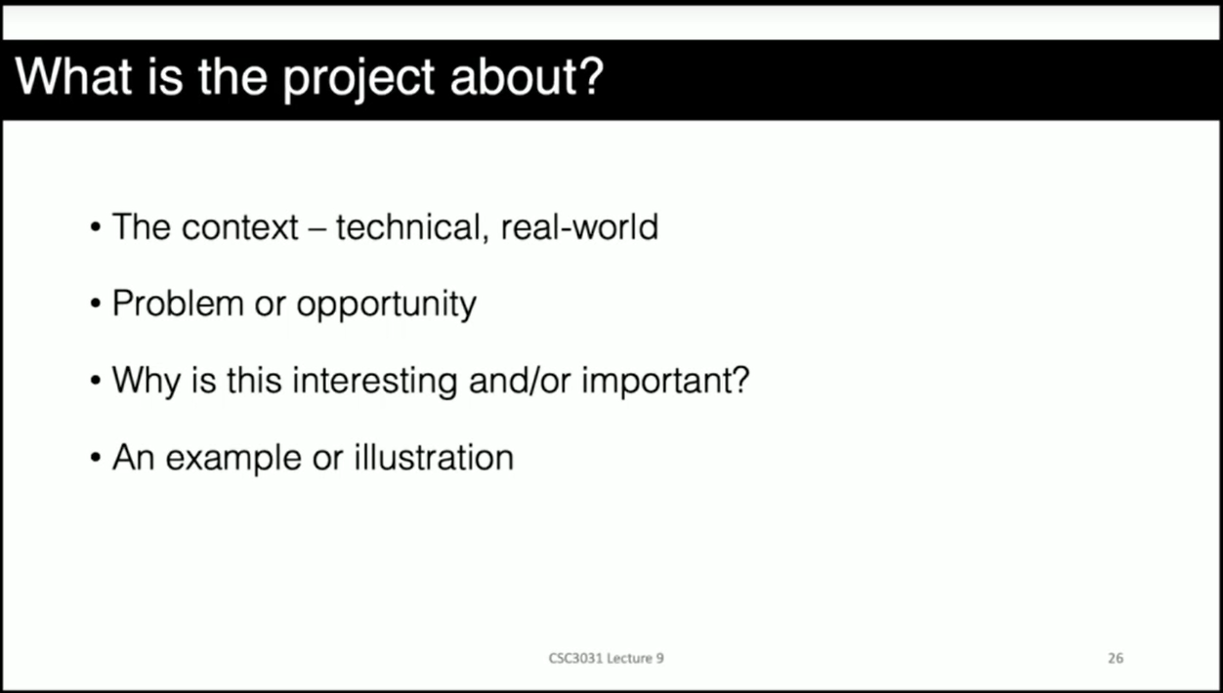

Probably add statistics

**GAMING POPULATION**

<https://www.investopedia.com/articles/investing/053115/how-video-game-industry-changing.asp> - Larger than the movie and music industries combined, and it is only growing. Over 2 billion gamers across the world. That is 26% of the world’s population

<https://www.statista.com/statistics/748044/number-video-gamers-world/> - how many video gamers there are

<https://venturebeat.com/2020/06/25/newzoo-over-3-billion-gamers-by-2023/> - 2.7 billion statistics

<https://newzoo.com/insights/articles/games-market-engagement-revenues-trends-2020-2023-gaming-report/> - more figures

<https://www.wepc.com/news/video-game-statistics/>

**GAMING/Entertainment/Media INDUSTRY Statistics**

<https://www.statista.com/chart/22392/global-revenue-of-selected-entertainment-industry-sectors/> - Gaming the most lucrative entertainment industry 2019

<https://www.digitalinformationworld.com/2020/10/gaming-recognized-as-the-most-profitable-industry-in-the-entertainment-sector-by-a-wide-margin.html>

<https://raiseyourskillz.com/gaming-industry-vs-other-entertainment-industries-2021/> - media revenue worldwide

**Disabled Gamers Statistics**

<https://www.worldbank.org/en/topic/disability#1> - One billion people, or 15% of the world’s population, experience some form of disability. ACCORDING TO WHO Disability World Report

<https://venturebeat.com/2019/10/08/accessibility-finally-matters-to-the-game-industry-but-it-needs-to-do-better/> - 92% percent of disabled people play games

<https://www.game-accessibility.com/documentation/around-92-of-people-with-impairments-play-games-despite-difficulties/> - similar

--- also says: “Accessible games equal bigger target audience”

<https://gameaccessibilityguidelines.com/why-and-how/> - 20% of casual gamers are disabled. Based on a survey of so many people

<https://ieeexplore.ieee.org/stamp/stamp.jsp?arnumber=6527252> – Cited PopCap Games Research

<https://www.gamesindustry.biz/articles/popcap-games-research-publisher-s-latest-survey-says-that-casual-games-are-big-with-disabled-people> - similar MAIN

<https://www.scope.org.uk/campaigns/research-policy/accessibility-in-gaming/> - 66 of surveyed scope employees have accessibility issues

1. **What are the project’s Aim/Hypothesis and Objectives about?**

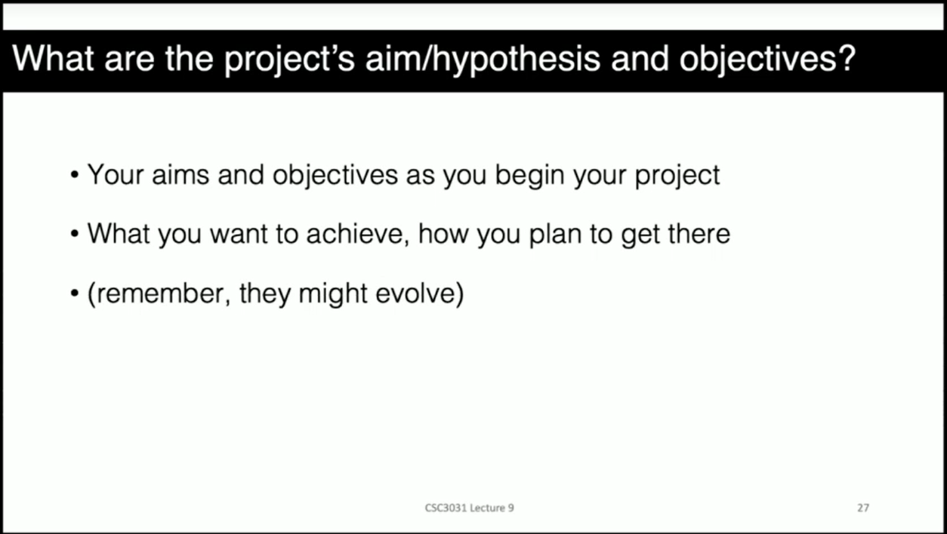

Dsfds

Ghghh

1. **How do you propose to tackle it?**

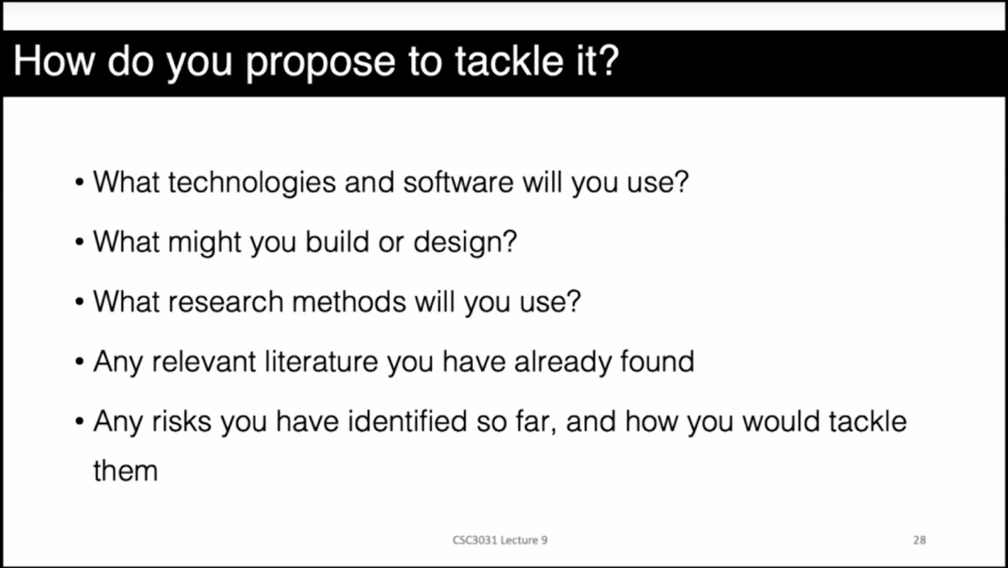

Dsfds

Agile Development – Feature Driven Approach

Ghghh

1. **What are your plans for the project?**

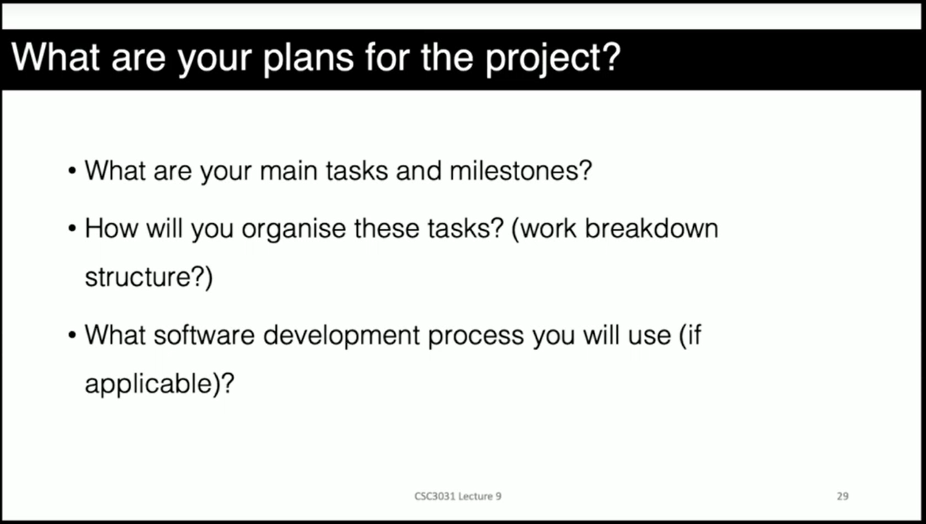

Dsfds

Something like:

Plan for Week 1: Research

Plan for Week 2: Prototype and show them to supervisors to get preliminary feedback before integrating it into main artefact

Plan for Week 3: Presentation

Plan for Week 4: Proposal

Plan for Week 5: Develop, evaluate, Write Dissertation

LAST PAGE:  
Prob References

ALSO: CONTACT DETAILS – Say something like “If you have any questions, recommendations & suggestions; here’s how you can reach me. Thank you for taking time to listen to presentation and do enjoy the rest of your day.”

**Project Idea/Outline**

Explore and implement methods that can cater towards players/users with accessibility difficulties. Develop and evaluate a game in terms of its accessibility features.

**Title Draft 1:** Accessibility in Games: Integrating video game accessibility features *to lower* ***accessibility barriers*** faced by people with disabilities.

(I like the sound of the first one, except it repeats the word “accessibility” to soon just after the first one is mentioned)

**Title Draft 2:** Accessibility in Games: Integrating video game accessibility features *to lower* ***barriers to access*** faced by people with disabilities.

**Aims**

**Aims DRAFT 1:** To develop a *video* ***game****,* *using the* ***Unity Engine***, which incorporates accessibility features that *cater* ***for*** *players with accessibility* ***difficulties****.*

**Aims DRAFT 2:** To develop a ***Unity game*** which incorporates accessibility features that *cater* ***towards*** *players* ***facing*** *accessibility* ***issues****.*

**Aims DRAFT 3:** To develop a ***Unity game*** which incorporates accessibility features *to* ***help facilitate*** *the* ***experience and challenges******faced/encountered*** *by players with accessibility* ***issues****.*

(**Objectives must be SMART** )

**S** = Specific

**M** = Measurable

**A** = Appropriate/Achievable

**R** = Realistic: in terms of resources like time and skill

**T** = Time-bound/Time-related: in terms of assigning duration

**Objectives**

1.) Explore and ***identify/establish*** a set of common gaming accessibility barriers ***INCLUDING: Visual Impairments, Hearing, Motor, Cognitive etc***.

2.) ***Investigate/Examine*** accessibility guidelines in gaming and establish common “audio-visual” techniques or methods used to assist ***players/users*** facing accessibility barriers.

(**ALTERNATIVELY, Combine 1 & 2:** Explore and identify a set of common gaming accessibility barriers and investigate established audio-visual techniques that are used to assist players facing such accessibility barriers.)

3.) Develop distinct, individual prototypes focused on each selected accessibility barrier.

4.) Develop a game that integrates all accessibility techniques into the main game loop.

5.) Analyse and evaluate the performance impact of enabling accessibility features.

6.) Analyse and evaluate how well the integrated accessibility features satisfy established accessibility guidelines in gaming.

(**ALTERNATIVELY, Combine 5 & 6:** Analyse and evaluate how well the integrated accessibility features satisfy established accessibility guidelines in gaming as well as its impact on the game’s performance when it is enabled.)

Evaluate the game’s functionality (in terms of overall performance/FPS after turning on accessibility features compared to when it’s off --- determine scalability of techniques and how hardware intensive they are) and playability in terms of accessibility as in of how well it satisfies (or when compared against) “a certain online guideline”.

**WEBSITES AND REFERENCES:**

<https://caniplaythat.com/workshops/list/accessibility-reference-guides/> - CIPT (Can I Play That) Accessibility Reference Guides

<https://gameaccessibilityguidelines.com/full-list/> - Games Accessibility Guidelines

<https://accessible.games/includification/> - (Able Gamers Guide)

<https://accessible.games/wp-content/uploads/2018/11/AbleGamers_Includification.pdf> - Use Voice for Motor/Mobility Impairments (Able Gamers Guide)

“As we move through the guide, our focus shifts to gamers with more severe disabilities like spinal cord injuries, quadriplegics and advanced Multiple Sclerosis that require the most advanced eye tracking and voice recognition software available today "

Sdada

<https://www.theverge.com/22303517/disabled-players-game-accessibility-voice-control>

“WHEN GAMES ARE HARD ON THEIR HANDS, SOME PLAYERS TURN THEIR VOICES INTO CONTROLLERS”